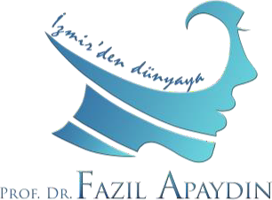
4th Apaydin Interactive Rhinoplasty Course
22-26 August 2022, Izmir-Turkey

Dear Colleagues,

This interactive course is limited to 6 ENT and Plastic surgeons. The aim is to share the experience of 30 years of in rhinoplasty in a peer-to-peer way. The reason to keep it to a minimum number of participants is to make the teaching more interactive and dynamic. By doing so, the participant will be able to comprehend all the details during that session.

Please see the main topics to be covered during first two days of this course below. The participants will not only listen to these lectures, but also will actively participate. Beside they will take pictures, will do facial analysis and imaging by themselves during the workshops. In other words, the surgeon will be able to do the surgery before going into surgery. They will learn to use Rhinobase and use it as well. All lectures will be given by myself. The course venue for the first two days is my private clinic at Cumhuriyet Bulvarı, No: 127/7, Alsancak-Konak, Izmir.

Program at a glance:

- 2 days of interactive lessons: 22-23 August, 2022. Venue: Apaydin private clinic
- 2 days of operations: 24-25 August, 2022. Venue: Ozel Saglik Hastanesi
- 1 day lamb head dissection: 26 August, 2022. Venue: Apaydin private clinic
4th Apaydin Interactive Rhinoplasty Course
Scientific Program
22 August 2022, | Monday
08:30-08:45 | Registration (Tea and cookies are available)
08:45-09:00 | Surgical Anatomy
09:00-09:30 | Rhinoplasty consultation
09:30-10:00 | Facial analysis
10:00-10:30 | Rhinobase
10:30-11:00 | Coffee break
11:00-12:00 | Facial analysis workshop
12:00-12:30 | Photography, Imaging
12:30-13:30 | Photography workshop
13:30-14:30 | Lunch
14:30-15:30 | Imaging workshop
15:30-15:50 | Rhinoplasty: Step by step
15:50-16:10 | Incisions and approaches
16:10-16:40 | Septal surgery
16:40-17:00 | Profile alignment
17:00-17:30 | Coffee break
17:30-17:50 | Lateral crural procedure
17:50-18:10 | Osteotomies, Push-down, Let-down techniques
18:10-19:00 | Review of the day
20:00 | Dinner
23 August 2022, | Tuesday
09:00-09:30 | Middle vault management
09:30-10:00 | Tip surgery (Suture techniques)
10:00-10:30 | Tip surgery (Tip grafts)
10:30-11:00 | Coffee break
11:00-11:20 | Surgical instruments
11:20-12:00 | Preservation rhinoplasty
12:00-13:00 | Lunch
13:00-13:20 | Surgery of the nasal base
13:20-13:50 | Saddle nose
13:50-14:20 | Revision rhinoplasty (Use of conchal cartilage)
14:20-15:00 | Revision rhinoplasty (Use of costal cartilage)
15:00-16:00 | Presentation of the cases that will be operated
16:00-17:00 | Review of the day
19:00-22:00 | Video session - Private clinic of Prof. Apaydin – Dinner included
24 August 2022, | Wednesday
08:00 | Transfer to Private Sağlık Hospital – Pickup from the private clinic of Prof. Apaydin
20:00 | Dinner
25 August 2022, | Thursday
08:00 | Transfer to Private Sağlık Hospital – Pickup from the private clinic of Prof. Apaydin
19:00-22:00 | Video session - Private clinic of Prof. Apaydin – Dinner included
26 August 2022, | Friday
09:00-13:00 | Lamb head dissection - Private clinic of Prof. Apaydin
13:00-14:00 | Lunch
14:00-18:00 | Lamb head dissection - Private clinic of Prof. Apaydin
18:00 | Certificate presentation
20:00 | Dinner
27 August 2022, | Saturday
 | Izmir tour, tour to Ephesus, beach visit (Optional)

The operations will be performed at the Private Gazi Hospital. The participants will be in the OR to watch the surgeries. The surgeries will be recorded by video cameras. The participants will be able to learn the fundamentals of how to do audiovisual recording as well. There will be 4 surgeries in two days. The participants will be able to scrub and interact with me in the OR by their questions. The video of the operative field will also be reflected on a monitor. The videos of these patients will be edited and be given to the participants.

I have been using the lamb head as a teaching model for dissection for years with great success with my fellows and residents. The participants will be able to try all kinds of surgical techniques with me during lamb head dissection. The instruments will be supplied by us.

I am pretty sure that it will be a very fruitful learning experience for both the novice and seasoned rhinoplasty surgeons. I have been using interactive teaching techniques for a long time at the university and at the academic environment. They are best suited for small groups like this. In my opinion, it is the best teaching technique as well. That is why this course is limited to 6 colleagues.

Registration fee is 3500 Euros or 4000 US Dollars. It can be paid on site or can be transferred to the account sent to you by my secretary. Registration fee also covers the coffee breaks, lunches and and dinners, but not the boarding and travel expenses. There are very nice and inexpensive hotels in Izmir. The closest ones to my office which is 5-minutes walking distance is Swissotel Izmir and
Mövenpick Hotel. You can make reservations by your own

Course secretariat:
Dr. Şebnem Apaydın:

E-mail: sebo2343@gmail.com
Cellphone: 0090-532-4541036

Izmir is one of the most beautiful cities of Turkey. Please do not miss the opportunity to see the city. A historical bazaar tour and Izmir city tour will be part of our social program. All these activities are complimentary. The Turkish people are well-known for their hospitality. We will do our best to make your visit to Izmir as pleasant as possible. I highly recommend you to spend at least one or two days before or after the course to see the city more, to visit Ephesus and/or visit a nearby beach.

I look forward to meeting you in Izmir in August. Sincerely Yours,
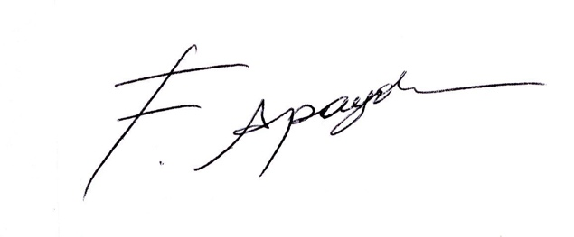

Prof. Dr. Fazıl Apaydın

